CREATIVE EDUCATIONAL SERVICES
END OF TERM TWO EXAMINATIONS 2024
PRIMARY ONE

MATHEMATICS

Name _______________________________________ Stream __________
Date _________________________________
Read the Instructions
- This paper is made up of 2 sections. A and B
- Section A carries 40 marks and Section B carries 60 marks.
- Please show the working where necessary.

SECTION A: (40 MARKS)
- Write in figures.
Seven = _________
- Circle the bigger number.
6 and 9 ____________
- Fill in the missing numbers.
10, 20, 30, ______, 50, 60.
- Add correctly.
4 chairs + 6 chairs = _____________ chairs
- Name this shape.

____________________________
- Write the number that comes before
________, 6

- Subtract / Take away
9
– 5

- Share equally.

8 ÷ 2 =

- Name this set.

A set of _______________balls.

- What is 5?
______ + _____ = 5

- Complete the abacus.
T O

6 3
- Circle the smallest number.
6, 9, 1, 4

- Fill in tens and ones
34 = ______tens ________ ones.

- Draw groups / multiply
4 x 2 = ______

- Join these sets.

+ =

- Arrange the numbers starting with the smallest.
5, 3, 7, 8 = _________________.

- Add correctly
T O
2 6
+ 3

- Work out.
+ 4 = 6
- How many legs do 5 boys have?

- Write in words
35 = _________________________
SECTION B
- Study the table and answer questions about it corectly.
Number of books. | 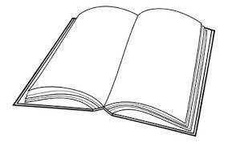
 | Joy | Sam | Jane | Ben

- Who has the biggest number of books?
________________________________________________________
- Who has the smallest number of books?
_______________________________________________________
- How many books has Sam?
________________________________________________________

- Work out correctly.
- 2 2 b) T O
x 3 4 2
+ 2 4

c) 10 – 3 = ______________ d) 10 ÷ 2 = ____________
- Study these sets and answer questions about them correctly.
Set A Set B

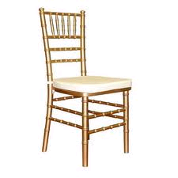

- How many members has set A?

- Which set has less members?

- How many members has set B?

- Which set has more members?

- Name these shaded fractions.
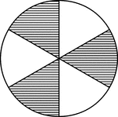
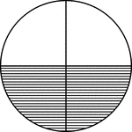
- b)

______________ ________________

- Write these numbers in words.
- 2nd = ___________________
- 40 = ___________________
- Write the following in figures.
- One hundred ________________________________
(ii) Twentieth ____________________________________

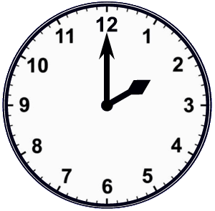
- Tell the time.

It is ___________ O’clock

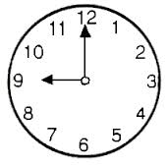

It is ____________ O’clock.

- What number has been expanded?
= __________

- 70 + 4 = ___________

- Find the next number.
- 2, 4, 6, 8, ________

- 5, 10, 15, ______

c) Add using the numberline.
3 + 4 =
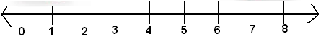

- How many eyes do 3 girls have?

- Which pencil is longer?
N M

Pencil pencil

Pencil ________ is longer than pencil __________

- Form and name new sets.
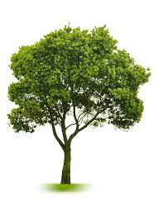
&
&
&
&

- Add correctly
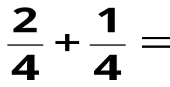

- How many days are in a week?

_________________________________________________________

